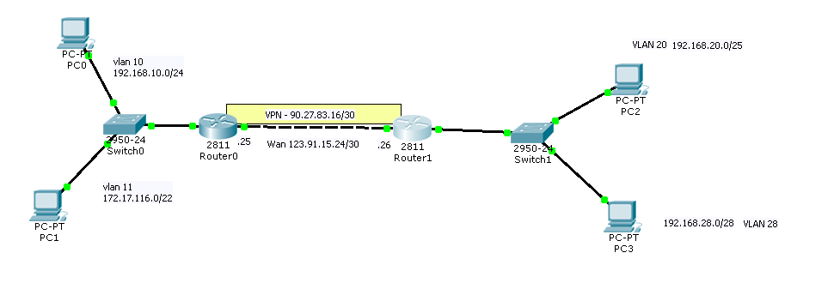

configurar nat entre um roteador e outro

Router 0

botar os ip nat inside e outside

hqrtr1(config)#ip access-list extended nat

hqrtr1(config-ext-nacl)#deny ip 192.168.10.0 0.0.0.255 192.168.20.0 0.0.0.127

hqrtr1(config-ext-nacl)#deny ip 172.17.116.0 0.0.3.255 192.168.20.0 0.0.0.127

hqrtr1(config-ext-nacl)#deny ip 172.17.116.0 0.0.3.255 192.168.28.0 0.0.0.15

hqrtr1(config-ext-nacl)#deny ip 192.168.10.0 0.0.0.255 192.168.28.0 0.0.0.15

hqrtr1(config-ext-nacl)# exit

hqrtr1(config) ip nat inside source list nat interface fa0/0

Router 1

rsrtr1(config)#ip access-list extended nat

rsrtr1(config-ext-nacl)#deny ip 192.168.20.0 0.0.0.127 192.168.10.0 0.0.0.255

rsrtr1(config-ext-nacl)#deny ip 192.168.20.0 0.0.0.127 172.17.116.0 0.0.3.255

rsrtr1(config-ext-nacl)#deny ip 192.168.28.0 0.0.0.15 172.17.116.0 0.0.3.255

rsrtr1(config-ext-nacl)#deny ip 192.168.28.0 0.0.0.15 192.168.10.0 0.0.0.255

rsrtr1(config-ext-nacl)#exit

rsrtr1(config)#ip nat inside source list nat interface fa0/0

Configurar interface Tunnel

Router 1

hqrtr1(config)#int tunnel 0

hqrtr1(config-if)#ip address 90.27.83.17 255.255.255.252

hqrtr1(config-if)#ip mtu 1400

hqrtr1(config-if)#ip tcp adjust-mss 1360

hqrtr1(config-if)#tunnel source 123.91.15.26 //ou interface de saida do trafego dele

hqrtr1(config-if)#tunnel destination 123.91.15.25

~~hqrtr1(config-if)#ip mtu 1400~~

Router 0

hqrtr1(config)#int tunnel 0

hqrtr1(config-if)#ip address 90.27.83.18 255.255.255.252

hqrtr1(config-if)#ip mtu 1400

hqrtr1(config-if)#ip tcp adjust-mss 1360

hqrtr1(config-if)#tunnel source 123.91.15.25 //ou interface de saida do trafego dele

hqrtr1(config-if)#tunnel destination 123.91.15.26

~~hqrtr1(config-if)#ip mtu 1400~~

OSPF

Router 0

hqrtr1(config)#router ospf 1

hqrtr1(config-router)#network 192.168.10.0 0.0.0.255 area 0

hqrtr1(config-router)#network 172.17.116.0 0.0.3.255 area 0

hqrtr1(config-router)#network 90.27.83.16 0.0.0.3

hqrtr1(config-router)#network 90.27.83.16 0.0.0.3 area 0

rsrtr1(config)#router ospf 1

rsrtr1(config-router)#network 192.168.20.0 0.0.0.127 area 0

rsrtr1(config-router)#network 192.168.28.0 0.0.0.15

rsrtr1(config-router)#network 192.168.28.0 0.0.0.15 area 0

rsrtr1(config-router)#network 90.27.83.16 0.0.0.3 area 0

Configurando VPN

Router 0

Router0(config)# crypto isakmp policy 1

Router0(?)# hash md5

Router0(?)# encryption 3des

Router0(?)# authentication pre-share

Router0(?)# lifetime 86400

Router0(?)# group 2

Router0(?)# exit

Router0(config)# crypto isakmp key 0 Oc@2014RS address 90.27.83.18

hqrtr1(config)#crypto ipsec transform-set TS esp-3des esp-md5-hmac

exit

ip access-list extended VPN-TRAFFIC

permit ip 192.168.10.0 0.0.0.255 192.168.20.0 0.0.0.127

permit ip 192.168.10.0 0.0.0.255 192.168.28.0 0.0.0.15

permit ip 172.17.116.0 0.0.3.255 192.168.20.0 0.0.0.127

permit ip 172.17.116.0 0.0.3.255 192.168.28.0 0.0.0.15

crypto map CMAP 10 ipsec-isakmp

set transform-set TS

hqrtr1(config-crypto-map)#set peer 90.27.83.18

match address VPN-TRAFFIC

exit

fazer a configuração acima nos 2 router mudando os IPS apenas e no final dela:

int fa0/0 (de saida)

crypto map CMAP

int tunnel 0

crypto map CMAP